To all prospective year 12 students and parents,

We are looking forward to welcoming all of the students to IB Mathematics courses in September. I am writing with some important information about studying IB mathematics, the requirement for Graphical Display Calculators and summer preparation work.

What level?
Although many students have already made choices about which IB Mathematics course they want to study, we want to make sure that the choices are both appropriate and realistic. It would be wise to consider the information provided here on the different IB courses if you haven’t already. In short we would like to achieve the best compromise of the following three aims,
- We would like everyone to be happy, confident and challenged in the courses they take.
- We would like all students to be doing the course that most suits their goals whatever they want to do next.
- We would like students to make realistic and sustainable choices.
We will spend some time at the start of year 12 talking about this and helping people to firm up decisions. It is worth spending some time looking now at requirements for different university courses or apprenticeships to help you decide. Our only real concern at this point is that if students have chosen Higher Level as one of their 3 HL subjects without a fourth option. If it becomes quickly apparent that HL is not the best choice then diploma students need to have another option. We will do everything we can to help, but just want to be clear that HL maths is a very demanding and difficult course. It is incredibly enjoyable for most students who do it, but can prove a problem for those for whom it is not the most realistic choice.

Summer Work
We have prepared some tasks for students to complete over the summer holidays before starting the course. We expect students to arrive in September with these completed. For HL and SL these tasks are considered as background knowledge and are essential for starting positively. For Maths Studies students, it is a short task designed to make sure that there is some mathematical activity over the summer and get students thinking. The details of the summer work are below…..
IB Mathematical Studies, SL – The details are in this document – Maths studies summer task
IB Mathematics Standard Level, SL – Please find a PDF attached that includes exercises and answers.
IB Mathematics Higher Level, HL - The details are in this document – Maths HL summer tasks
If students change their mind about which course they want to study then they should come back to this letter to find the task that goes with their choice.
We do ask please that all students complete the following response form to let us know they have received the task and answer a few quick questions.

Calculators
For IB students a graphical display calculator is a requirement of the course and students will be explicitly tested on their ability to use it.
We recommend the same calculator for all IB students. It is a significant advantage to have a good knowledge of your calculator and having examined our options, we feel that this calculator is the best one for students at IST.
All students should have the Casio calculator Casio fx-cg20. Please pay attention to the details and get this exact calculator (as listed in the parent handbook). There are pictures below. The calculator can be brought on amazon.fr At the time of writing, the cost was 122 €
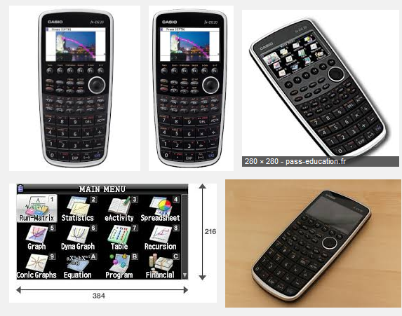

We recommend that students have ‘English Language’ versions of these calculators as this is the language of instruction (I suspect it is only available with English language keys for now). If students do not need the calculators after IB then many find they are able to sell their calculators on when the course is finished. We expect students to have these calculators with them when term starts in September.
Thank you for reading. If you have any questions about any of the above then please contact me, Jim Noble on noble_j@intst.net . We wish all of you a great summer look forward to starting the IB with you in September.

Jim Noble
Curriculum Leader for Secondary Mathematics
International School of Toulouse

